Project-

Chat With Retail Document(RAG)

Course Name: Generative AI

Institution Name: Medicaps University – Datagami Skill Based Course

Student Name(s) & Enrolment Number(s):
Sr no | Student Name | Enrolment Number
1. | Shubham Kumawat | EN22CS301943
2. | Shivanshu Verma | EN22CS301917
3. | Shivani Vishwakarma | EN22CS301913
4. | Shubh Kapadia | EN22CS301942
5. | Shobha Goswami | EN22CS301922

Group Name: Group 06D8
Project Number: DO-41
Industry Mentor Name:
University Mentor Name: Prof. Divya Kumawat
Academic Year: 2026

Problem Statement & Objectives
- Problem Statement
- Project Objectives
- Scope of the Project

Proposed Solution
- Key features (Just mention key features here no need to go into details)
- Overall Architecture / Workflow
- Tools & Technologies Used (If applicable)

Results & Output
Add the below details here:
- Screenshots / outputs
- Reports / dashboards / models
- Key outcomes

Conclusion
Mention a brief conclusion about your project summing up everything you have worked on and the key learning.
Future Scope & Enhancements

Problem Statement & Objectives

1. Problem Statement

In the retail industry, large volumes of documents such as reports, manuals, and policies are generated regularly. Extracting meaningful information from these documents manually is time-consuming and inefficient. Users often face difficulty in finding relevant insights quickly, which affects productivity and decision-making.
There is a need for an intelligent system that can process these documents and allow users to retrieve information efficiently using natural language queries.
2. Project Objectives
The objectives of this project are:
- To develop an AI-based system for interacting with retail documents
- To allow users to upload PDF documents
- To enable question answering using natural language
- To provide accurate, context-based responses
- To reduce manual effort in document analysis
- To improve efficiency and decision-making
3. Scope of Project
The scope of this project includes:
- Uploading and processing PDF documents
- Extracting and splitting text into manageable chunks
- Generating embeddings for semantic understanding
- Storing embeddings in a vector database (FAISS)
- Implementing a chat interface for querying documents
- Generating answers using a Large Language Model
Limitations:
- Supports only PDF documents
- Works on a single document at a time
- Depends on internet for LLM API

Proposed Solution

1. Key Features

• Document upload functionality
• Semantic search using embeddings
• Chat-based user interface
• AI-powered question answering
• Fast response using Gemini API
• Context-aware answers using RAG

2. Overall Architecture / Workflow
- User uploads a PDF document
- Backend processes and extracts text
- Text is divided into smaller chunks
- Each chunk is converted into embeddings
- Embeddings are stored in FAISS vector database
- User asks a question
- System converts query into embedding
- Relevant chunks are retrieved using similarity search
- Context + query is sent to LLM (Gemini)
- Final answer is generated and displayed
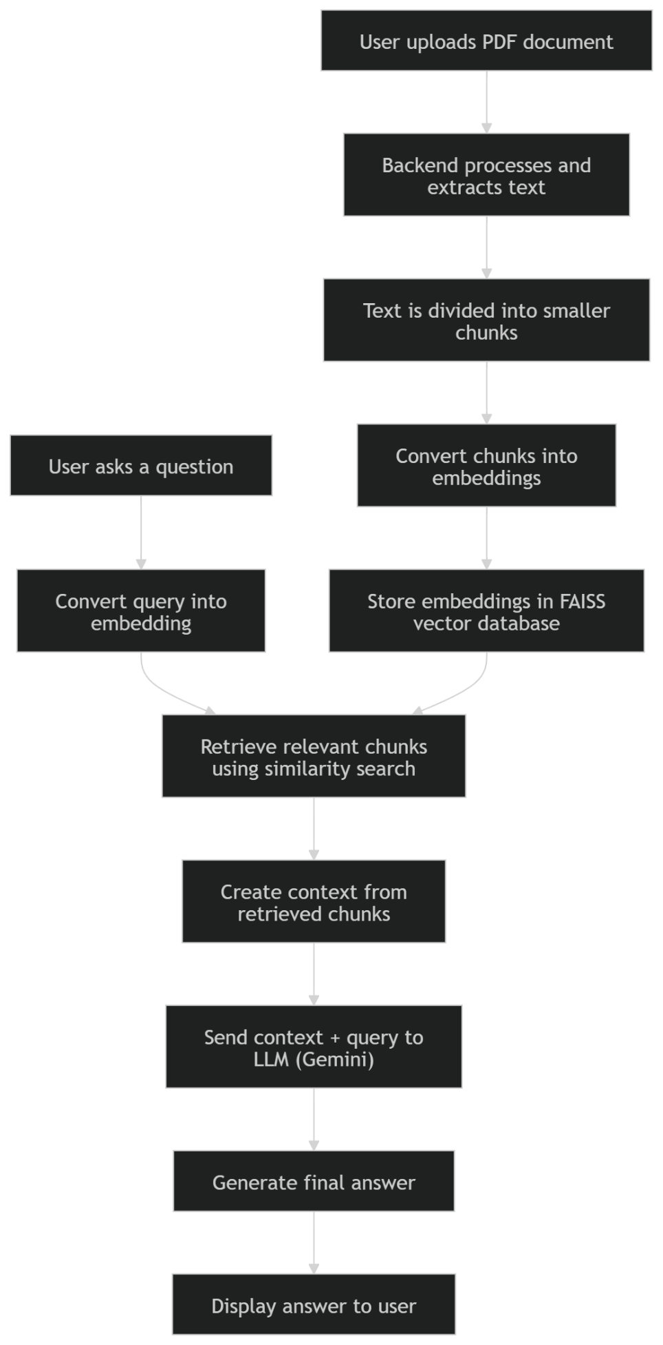

3. Tools & Technologies Used

Backend
- Python – Used for backend development and AI integration.
- FastAPI – Used to build fast and efficient APIs for handling requests.

Frontend
- React (TypeScript) – Used to create an interactive and responsive user interface.
- Tailwind CSS – Used for styling and designing the UI.

AI Technologies
- LangChain – Manages the RAG pipeline and integrates different components.
- all-MiniLM-L6-v2 – Converts text into embeddings for semantic search.
- FAISS – Stores embeddings and performs fast similarity search.
- Gemini 2.5 Flash – Generates answers based on retrieved context.

Other Tools
- Axios – Handles API communication between frontend and backend.
- Uvicorn – Runs the FastAPI server efficiently.

Results & Output
1. Screenshots
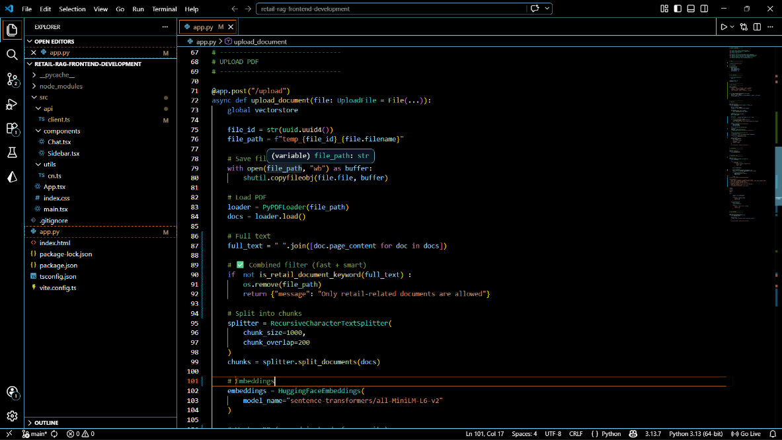
Pdf Upload Code
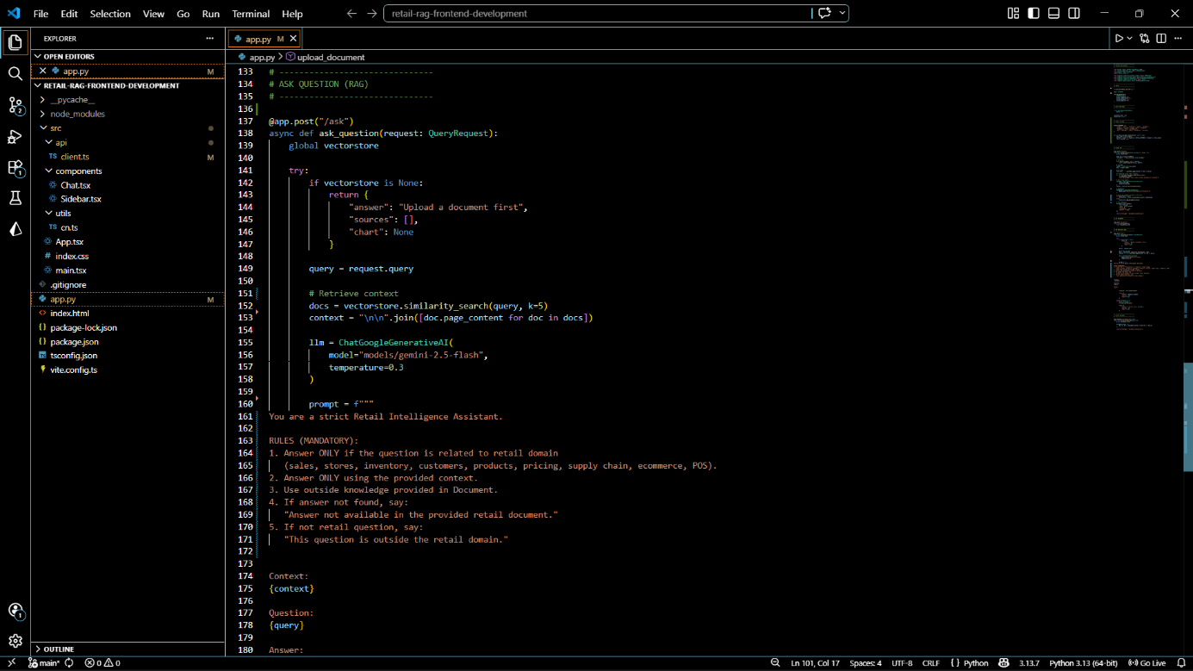
RAG code

2.Output
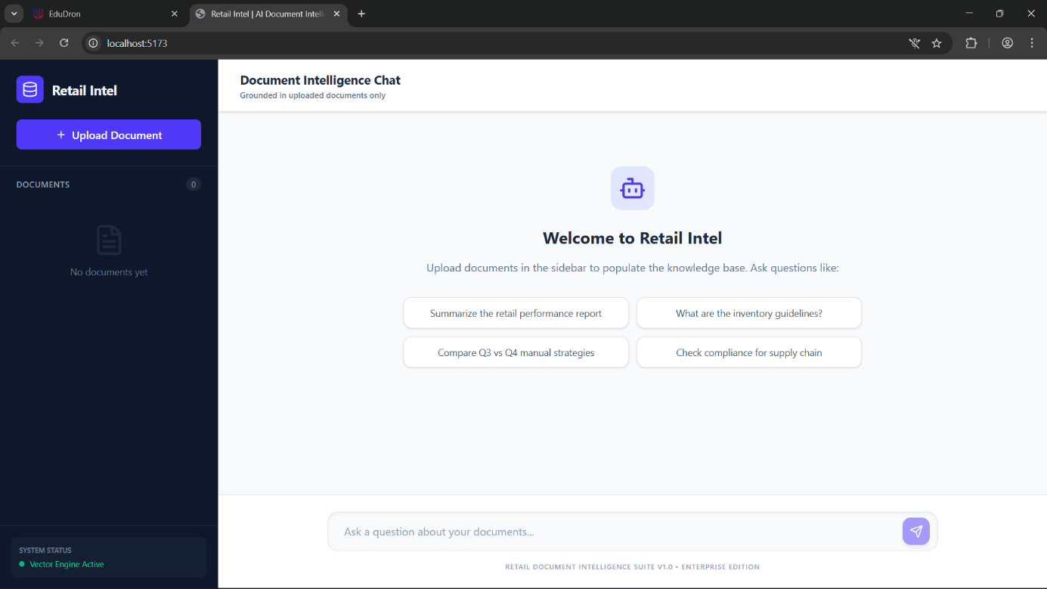
User Interface
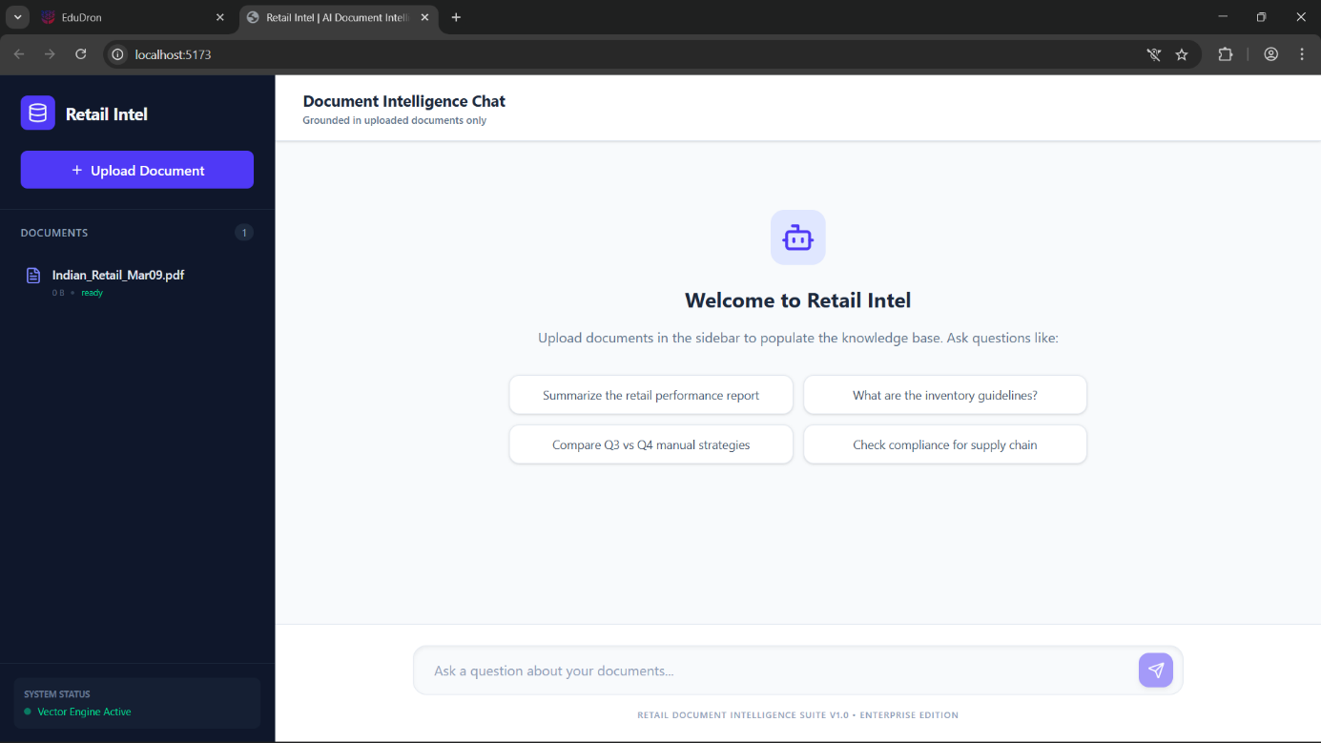
Pdf Uploading

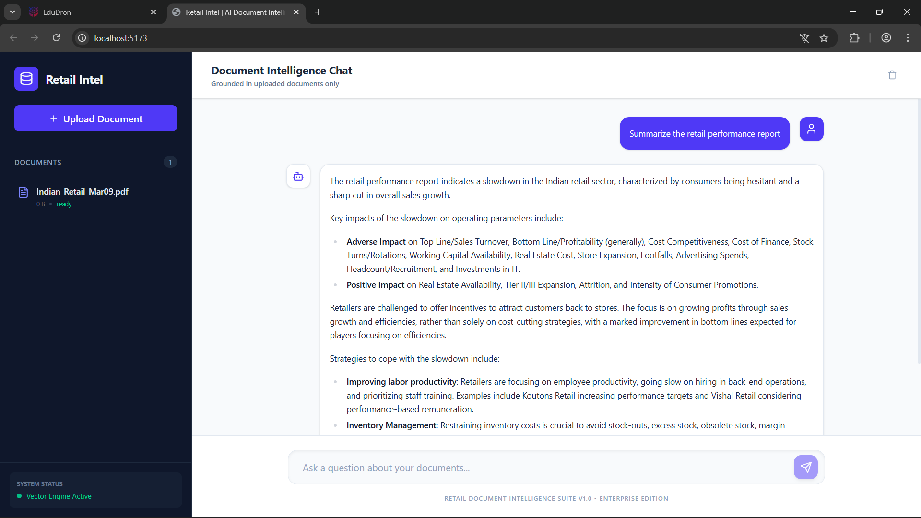
Chat With Document

3. Key Outcomes
- Successfully developed an AI-powered document chat system
- Achieved accurate and context-aware responses
- Reduced manual document reading effort
- Improved speed of information retrieval

Conclusion
This project successfully demonstrates the implementation of a Retail Document Intelligence System using Retrieval-Augmented Generation (RAG). The system enables users to interact with documents in a simple and efficient way through natural language queries.
By combining vector search and large language models, the system provides accurate and context-based answers, improving productivity and reducing manual effort.
The project highlights the practical use of AI in real-world applications and can be further enhanced by adding multi-document support, persistent storage, and advanced analytics.

Future Scope & Enhancements
The current system provides an effective solution for interacting with retail documents using AI. However, there are several improvements and enhancements that can be implemented in the future to make the system more powerful and scalable.

1. Multi-Document Support
The system can be extended to handle multiple documents simultaneously. Users will be able to upload and query across different documents without overwriting previous data.

2. Persistent Vector Database
Currently, the vector database is stored in memory. Future versions can use persistent storage (like a database) to retain data even after restarting the system.

3. Improved Accuracy
Accuracy can be enhanced by:
- Using advanced embedding models
- Fine-tuning LLMs
- Improving retrieval techniques

4. Advanced Search & Filtering
Add features such as:
- Keyword + semantic search
- Filters based on document type, date, or category

5. Better User Interface
Enhancements in UI/UX can include:
- Chat history
- Document preview
- Highlighting answers in the document

